| **Date** | 20-09-2022 |
| --- | --- |
| **Student Name** | Sajjan Amarnath Sithu |
| **Student Roll Number** | 194112 |
| **Maximum Marks** | 2 Marks |

ASSIGNMENT 3

1. Create a Bucket in IBM object storage.

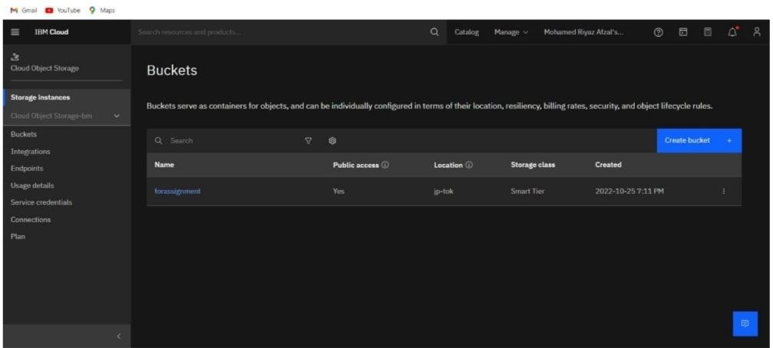

1. Upload an 5 images to ibm object storage and make it public. write html code to displaying all the 5 images.

<!DOCTYPE html>

<html>

<head>

<title>NAME</title>

</head>

<body><centre>

<link rel="stylesheet"

href="https://pro-images.s3.jp-tok.cloud-objectstorage.appdomain.cloud/NAME.css">

<div style="border: 1px solid #FF7FO0;margin: 1Opx;">

<h3>MONUMENT 1</h3>

<img src = "https://pro-images.s3.jp-tok.cloud-objectstorage.appdomain.cloud/monu2. jpg"

alt = "Expense Tracker" height = "250" width = "270" />

<h3>MONUMENT 2</h3>

<img src =

"https://pro-images.s3.jp-tok.cloud-objectstorage.appdomain.cloud/monu4.jpg" alt = "Expense Tracker" height = "250" width = "270" />

<h3>MONUMENT 3</h3>

<img src =

"https://pro-images.s3.jp-tok.cloud-objectstorage.appdomain.cloud/monu5.jpg"

alt = "Expense Tracker" height = "250" width = "270" />

<h3>MONUMENT 4</h3>

<img src =

"https://pro-images.s3.jp-tok.cloud-objectstorage.appdomain.cloud/monu6.jpg" alt = "Expense Tracker" height = "250" width = "270" />

<h3>MONUMENT 5 </h3>

<img src =

"https://pro-images.s3.jp-tok.cloud-objectstorage.appdomain.cloud/monu8.jpg" alt = "Expense Tracker" height = "250" width = "270" />

<h3> </h3>

</centre> </body>

</html>

1. Upload a css page to the object storage and use the same page in your HTML code.

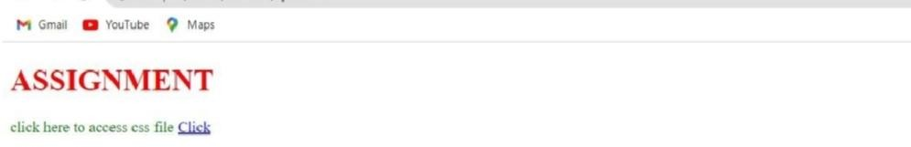

1. Design a chatbot using IBM Watson assistant for hospital. Ex: User comes with query to know the branches for that hospital in your city. Submit the web URL of that chat bot as an assignment.

<html>

<head>

<title> IBM Hospital </title>

<link href="style.css" type="text/css" rel="stylesheet">

</head>

<body>

<div class="top">

<div>

Contact Us +91 9876543210 / 01 | [IBM@hospital.com](mailto:IBM@hospital.com)

</div>

</div>

<div class="logo">

<div>

<table>

<tr>

<td width="600px"

style="font-size:50px;font-family:forte;"> <font color="#428bca"> IBM </font><font color="#000"> Hospital</font> </td>

<td> <br> <br>

<font size="4px">

<a href="index.html">HOME</a>

</font>

</div>

</div>

</tr>

</table>

</td>

<div class="middle">

<div style="background-image:url('a.jpg');">

<p>

<br> <br>

Health Care Services <br>

</div>

</p>

</div>

<font size="5px"> We Care About Your Health </font>

<div class="bottom">

<div>

<table border="0">

<tr>

</font> <br> <br>

<td width="700px">

<font color="#000"> We are medical center

<font color="#000" size="5px"> We Have Medicare Plan Options for You! </font> <br> <br>

Phasellus pretium orci sit amet mi ullamcorper egestas. Sed non mattis metus. Integer vel lorem tincidunt, pharetra eros nec, posuere odio. Nullam eget bibendum sem, venenatis lacinia justo. Duis aliquet lobortis neque, eget volutpat nulla iaculis a.

<br><br>

In hac habitasse platea dictumst. Praesent condimentum justo justo, at ultricies diam accumsan vitae. Donec ac elementum diam. Ut quam orci, posuere quis lacus sed, vehicula rhoncus massa. Nunc volutpat nibh nulla, tincidunt egestas tellus faucibus nec. <br><br>

<ul>

<li> Nulla venenatis auctor quam, ac porta lectus dictum in

<li>Aliquam sodales nisi sit amet lorem

<li>Suspendisse vulputate tellus in justo convallis imperdiet

<li>Morbi id lorem consequat, sodales mi non

<li>Nulla venenatis auctor quam, ac porta lectus dictum in

</ul>

<br>

</td>

<td> </td>

</tr>

</div>

</div>

</table>

<div class="nav_down">

<div>

&copy; IBM Hospital

</div>

</div>

<script>

window.watsonAssistantChatOptions = {

integrationID: "7ac9e983-44d3-4759-9695-71c921d63f88", // The ID of this integration.

region: "au-syd", // The region your integration is hosted in. serviceInstanceID: "77b07d96-db8c-4be1-833f-4e9a8cdefc61", // The ID of

your service instance.

onLoad: function(instance) { instance.render(); }

};

setTimeout(function(){

const t=document.createElement('script');

t.src="https://web-chat.global.assistant.watson.appdomain.cloud/versions/" + (window.watsonAssistantChatOptions.clientVersion || 'latest') + "/WatsonAssistantChatEntry.js";

document.head.appendChild(t);

});

</script>

</body>>

</html>

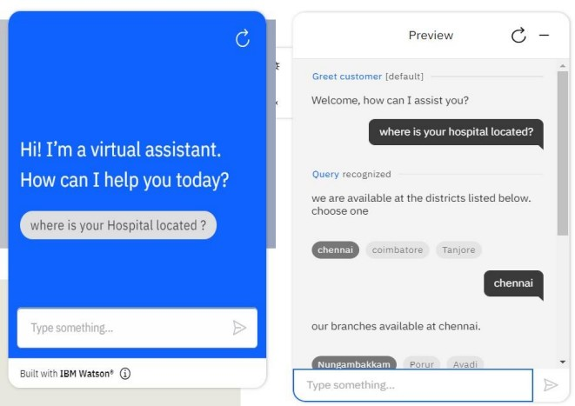

1. Create Watson assistant service with 10 steps and use 3 conditions in it. Load that script in the HTML page.

